Assignment:

Power BI Assignment 2 – DAX & Data Visualization:

Calculated Columns:
● Create a Calculated Column for 'Category Type':
Add a calculated column in the Order Details table that combines the 'Category' and 'Sub-Category' columns into a single 'Category Type' column.

Steps:
Go to power bi select the Order details table choose the new column in table tools
Apply the formula between ‘Category’ &'Sub-Category'
then enter we have to create new column
Use & operator to concatenates and “ ” use this separator
Category Type = 'Order Details'[Category] &" "& 'Order Details'[Sub-Category]

Screen short:
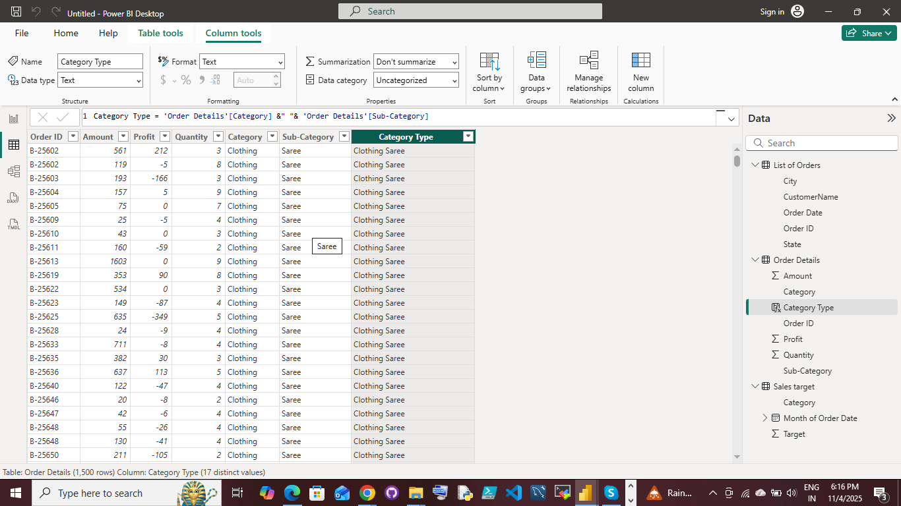

● Calculate Revenue per Order in Order Details Table:
Create a calculated column in the Order Details table to compute the revenue (Amount * Quantity) per order.

Steps:
Go to power bi select the Order details table choose the c in table tools
Apply the formula between the amount and quantity
then enter
we have to create new column revenue per order
Use * operator to find the revenue per oders

revenue per order = 'Order Details'[Amount]*'Order Details'[Quantity]

Screenshot:

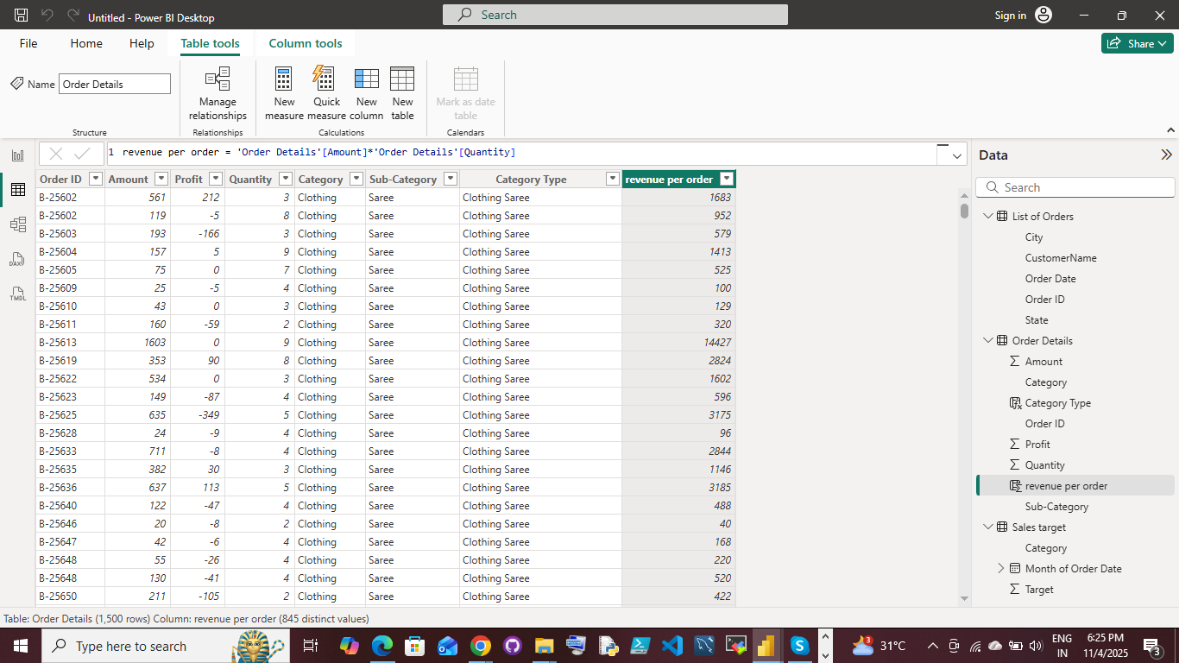

● Create a Calculated Column to Categorize Sales: Add a calculated column named ‘Sales Category’ in the Order Details table that categorizes each order as 'Above Average' or 'Below Average' based on the Amount value.

Steps:
Go to power bi select the Order details table choose the new column in table tools
Apply the formula
then enter
we have to create new column Sales Category
find the Average in Amount and use IF conditions to get 'Above Average' or 'Below Average categorizes each order

Sales Category = IF('Order Details'[Amount]>=AVERAGE('Order Details'[Amount]), "Above Average", "Below Average")

Screen short:
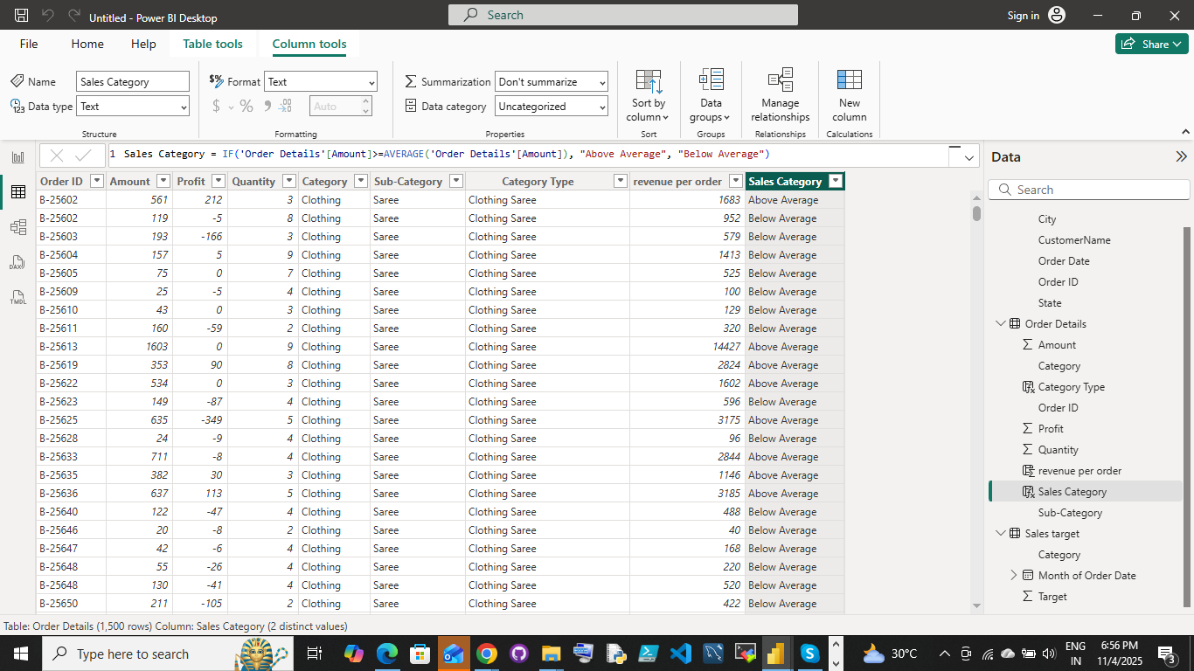

Calculated Measures:
● Calculate Order Count: Define a measure to count the total number of orders in the Order Details table.
Steps:
Go to power bi select the Order details table choose the new measure in table tools
Apply the formula
Order Count = DISTINCTCOUNT('Order Details'[Order ID])
Use distinct count for uniq orderedID in the order
After we have to move report view just drag and drop the order count into
Build visual tool to get the count

Screenshort:
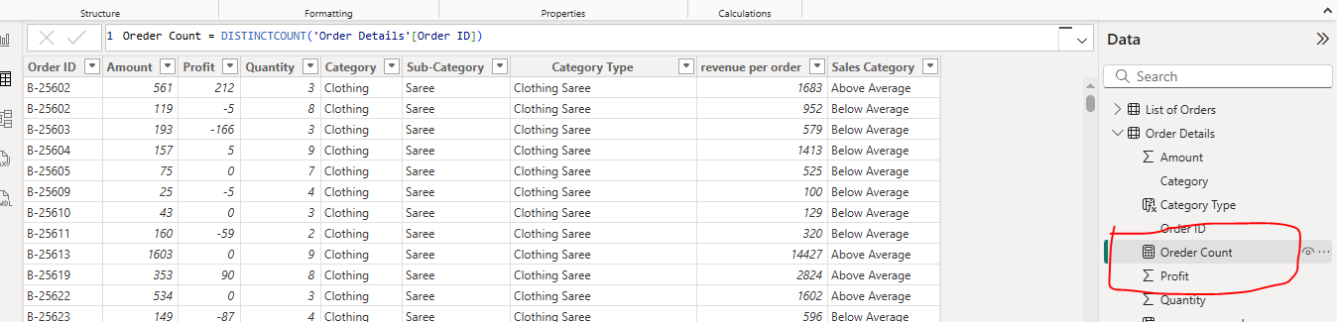
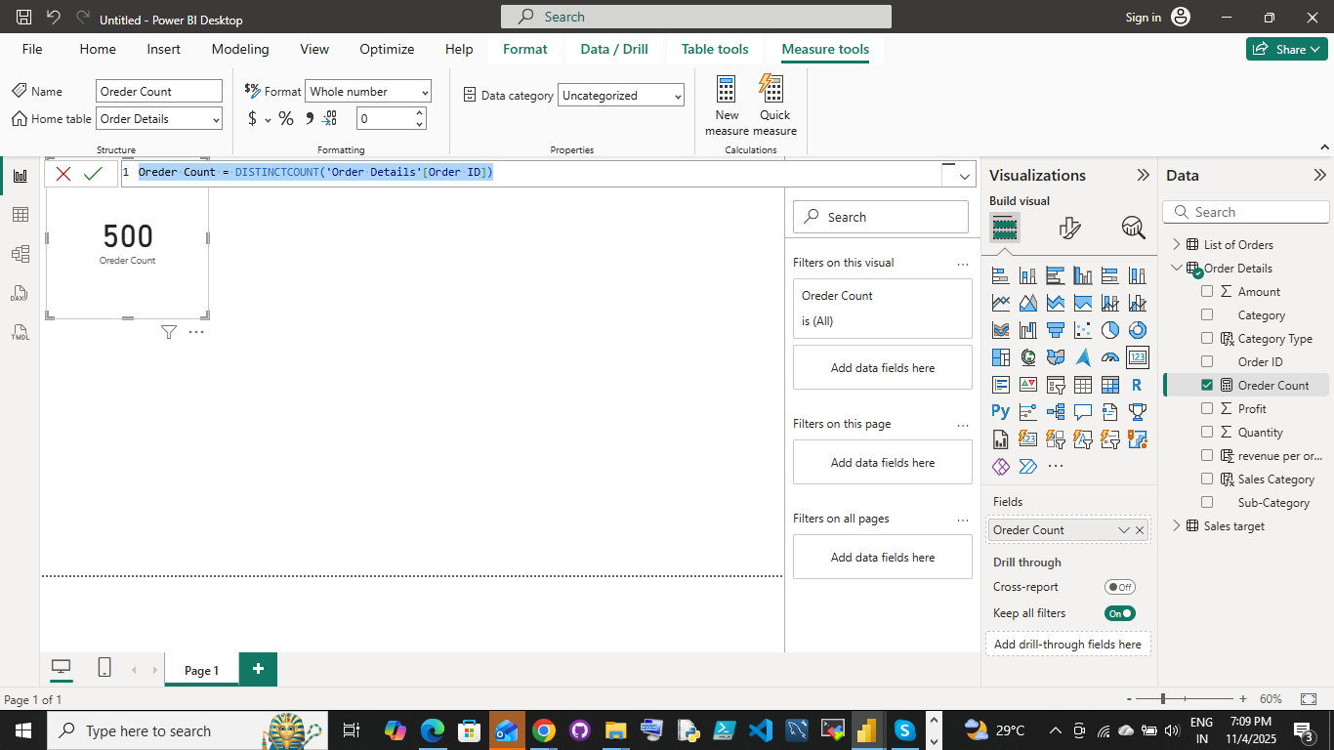

● Calculate Average Profit in Delhi: Create a measure to calculate the average profit for orders placed in Delhi.
Step: Steps:
Go to power bi select the Order details table choose the new measure in table tools
Apply the formula

average profit of Delhi = CALCULATE(AVERAGE('Order Details'[Profit]),'List of Orders'[City]="Delhi")
using two table Order details and list of orders

Screenshort:

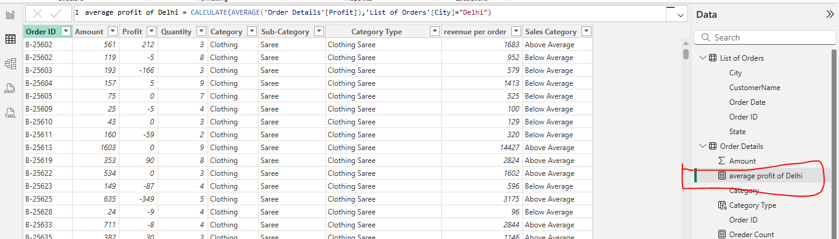
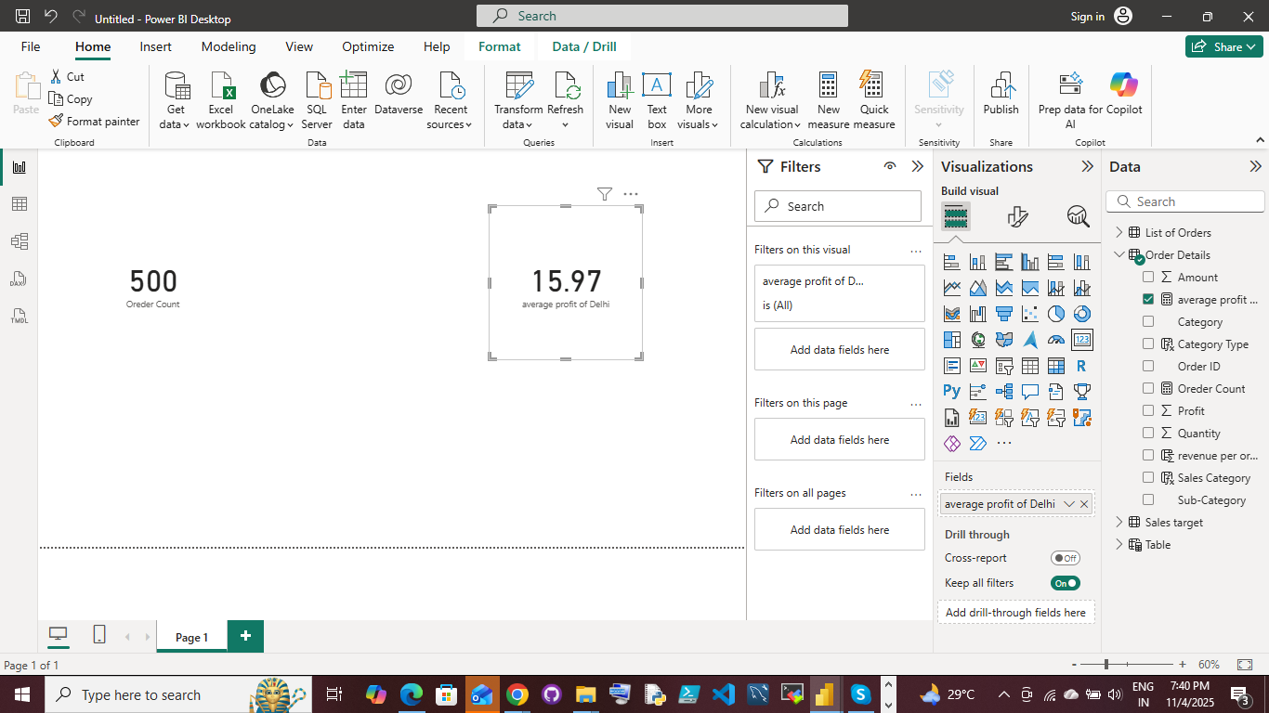

● Calculate Year-to-Date (YTD) Sales:
Define a measure to calculate the total sales amount accumulated from the earliest order date up to each order date.
Steps:
Step: Steps:
Go to power bi select the Order details table choose the new measure in table tools
Apply the formula

Year-to-Date (YTD) Sales = CALCULATE(SUM('Order Details'[Amount]),FILTER(ALL('List of Orders'[Order Date]),YEAR('List of Orders'[Order Date]) = YEAR(MAX('List of Orders'[Order Date])) &&'List of Orders'[Order Date] <= MAX('List of Orders'[Order Date])))

Using two table order details and list of orders
Screenshort:
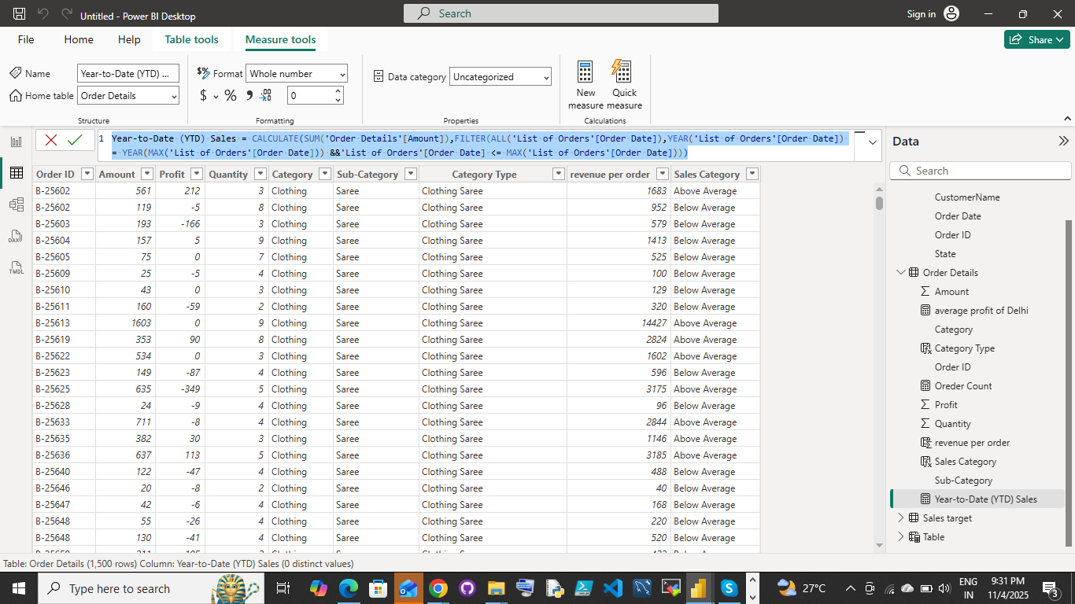
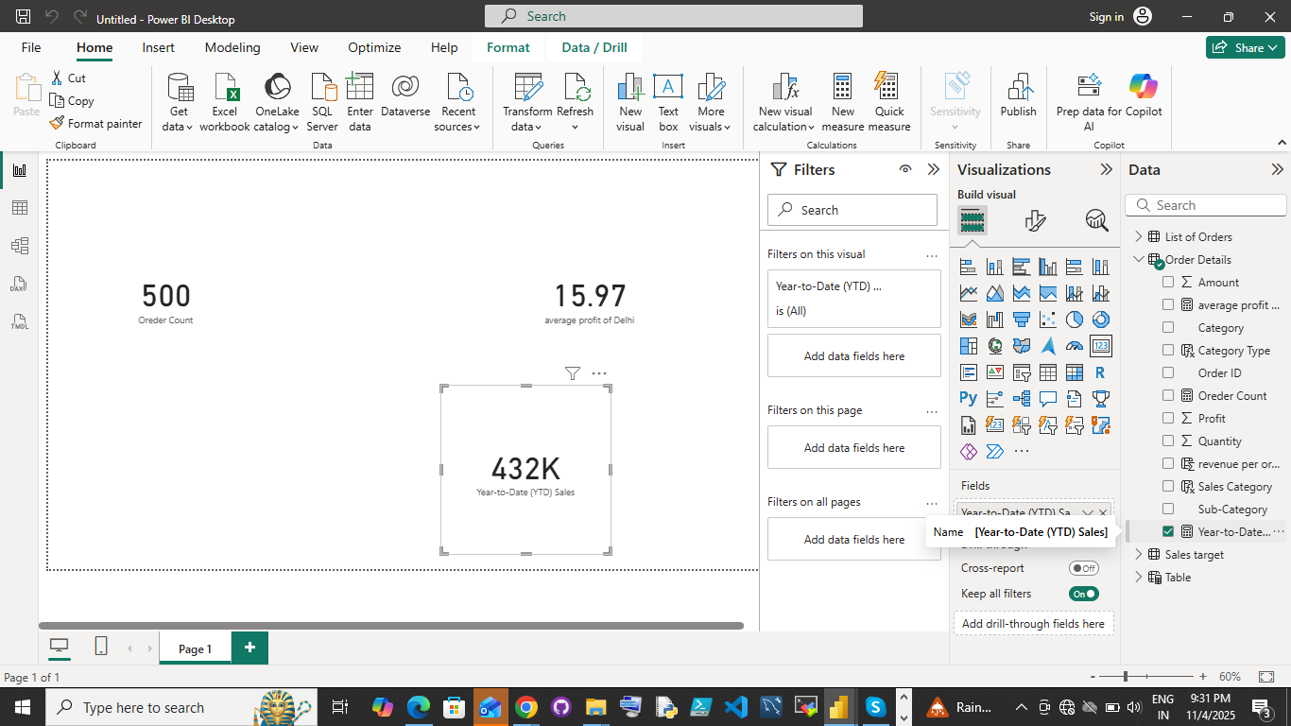

Data Visualization:

Sales Target Achievement by Category: Compare actual sales with sales targets by category using a clustered column chart.

Screenshort:

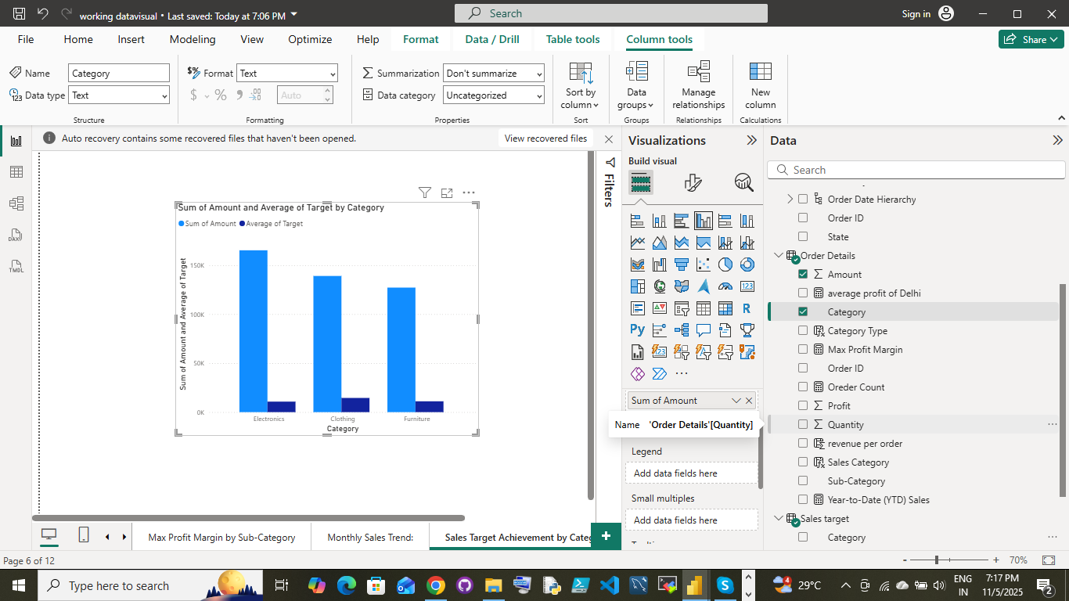

Max Profit Margin by Sub-Category: Analyze the maximum profit margin for each sub-category of products using a donut chart.

Screen short:

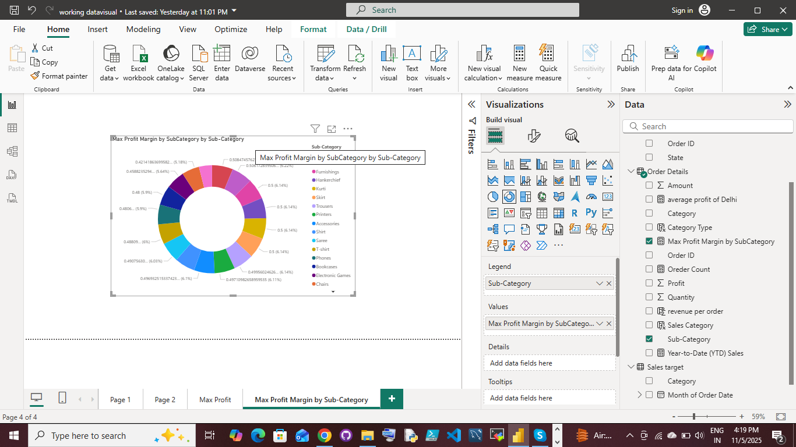

Monthly Sales Trend: Show the trend of monthly sales over time using a line chart.

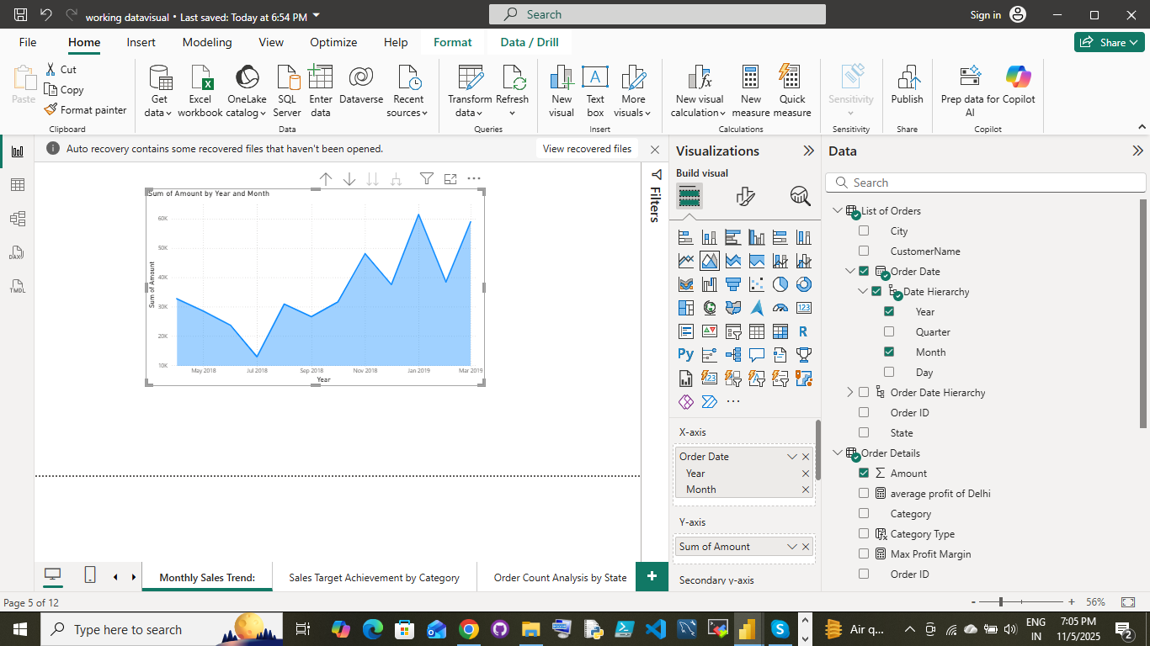
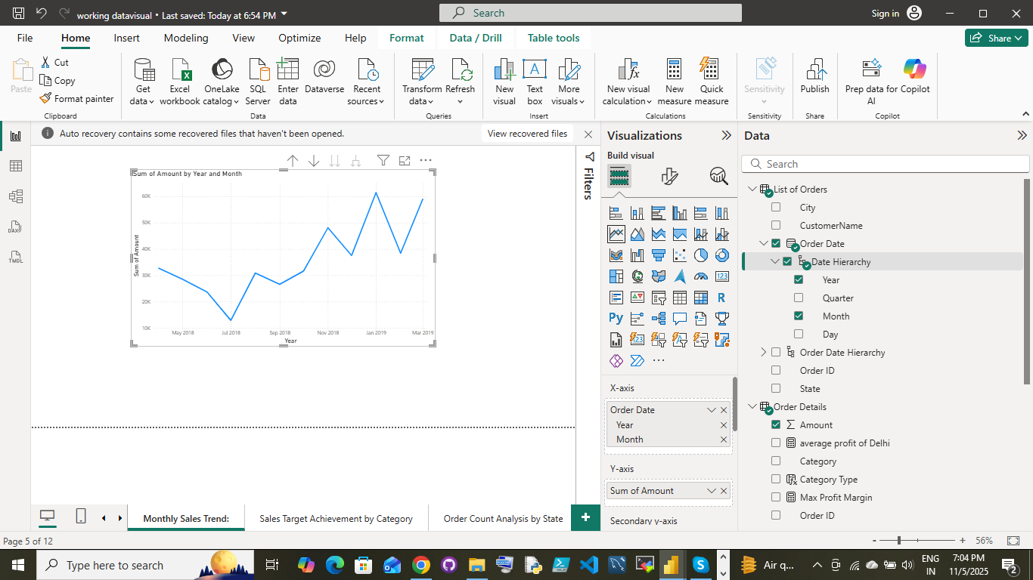

Comparison of Profit and Quantity by Sub-Category: Compare the relationship between profit and quantity sold for different sub-categories using a scatter chart.

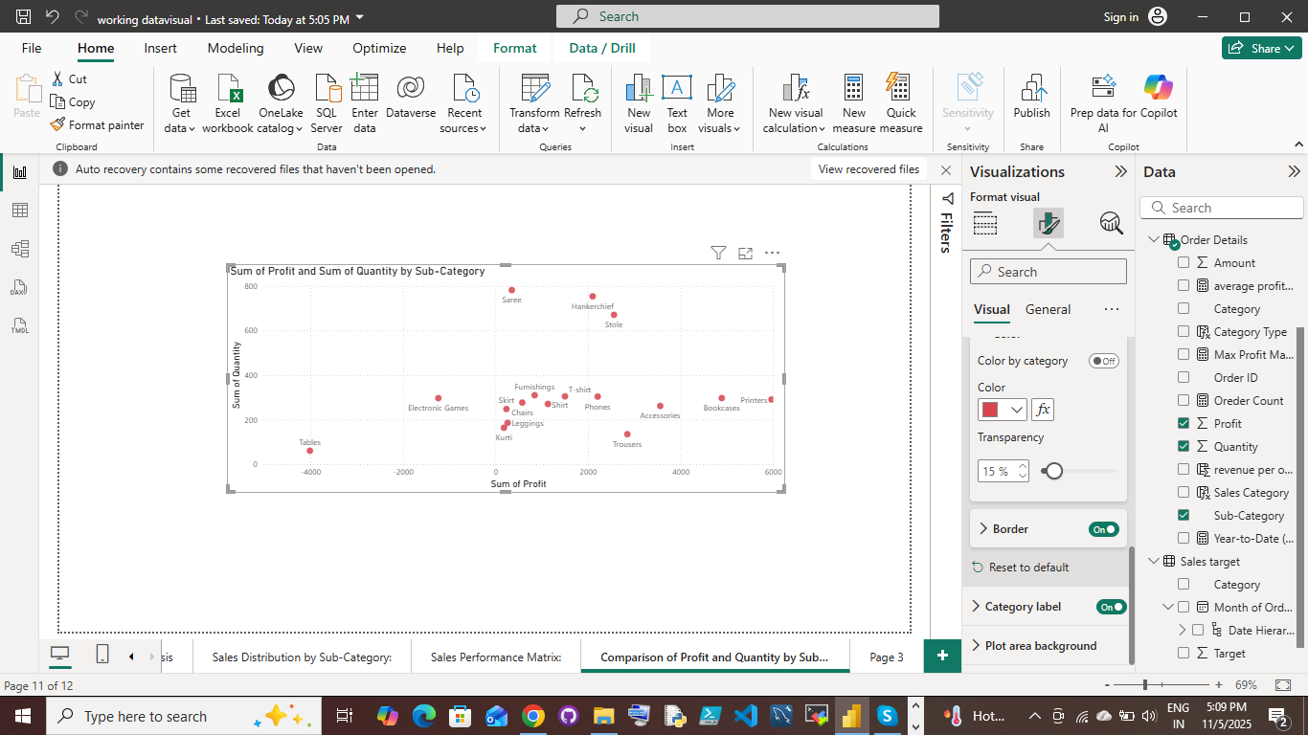

Comparison of Total Sales Amount and Target: Create cards to succinctly display the total sales amount alongside the sales target for quick comparison and analysis. Also, create a multi-row card to display the minimum target for each segment.

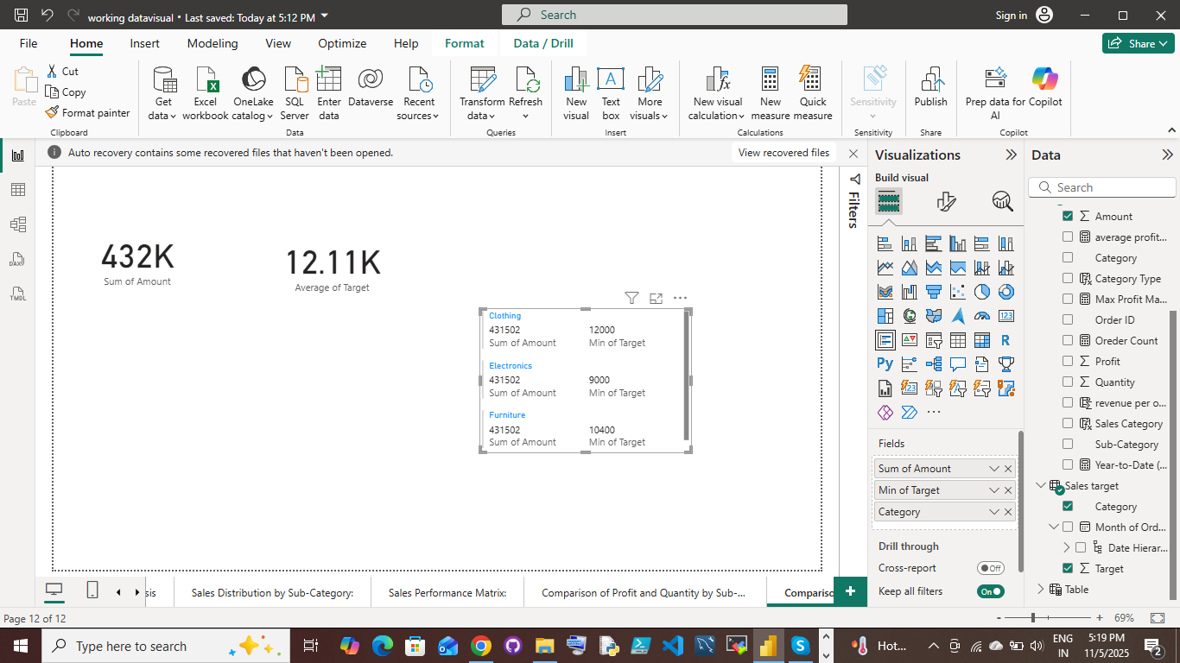

Sales Performance Matrix: Build a matrix view to analyze how actual sales compare to sales targets across different categories and months.

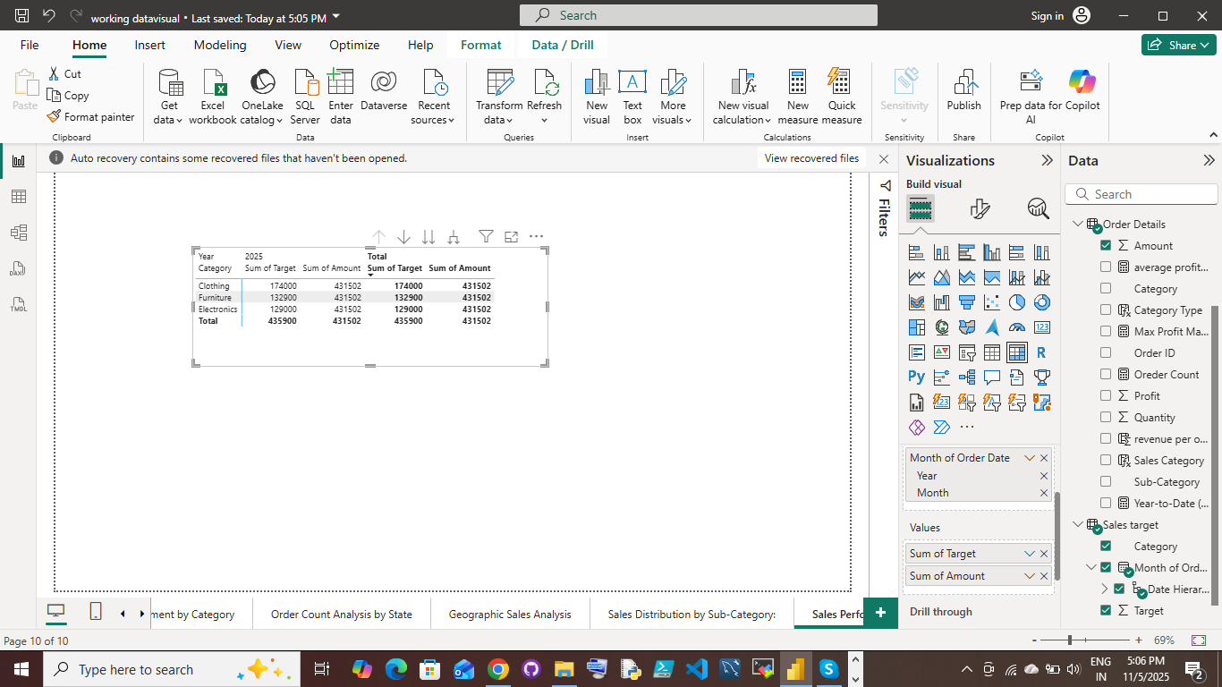

Geographic Sales Analysis: Visualize total sales on a map by city to identify regional sales patterns.
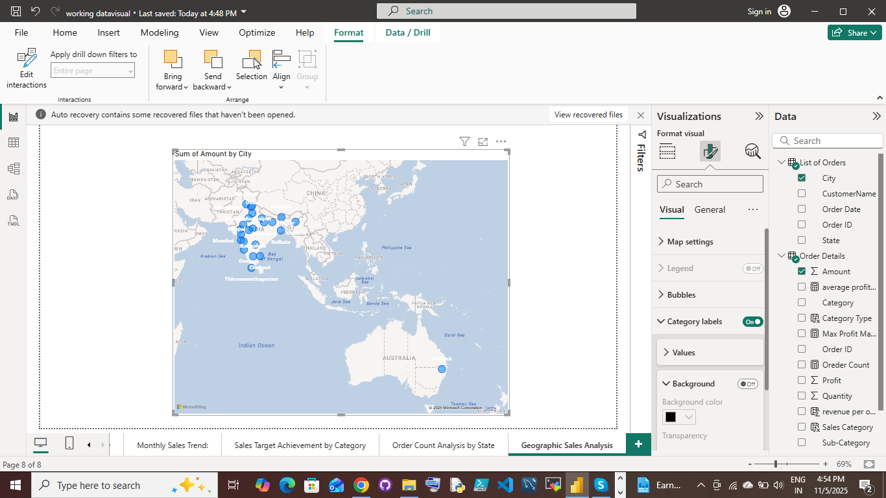

Sales Distribution by Sub-Category: Represent the sales distribution across different sub-categories using a treemap.

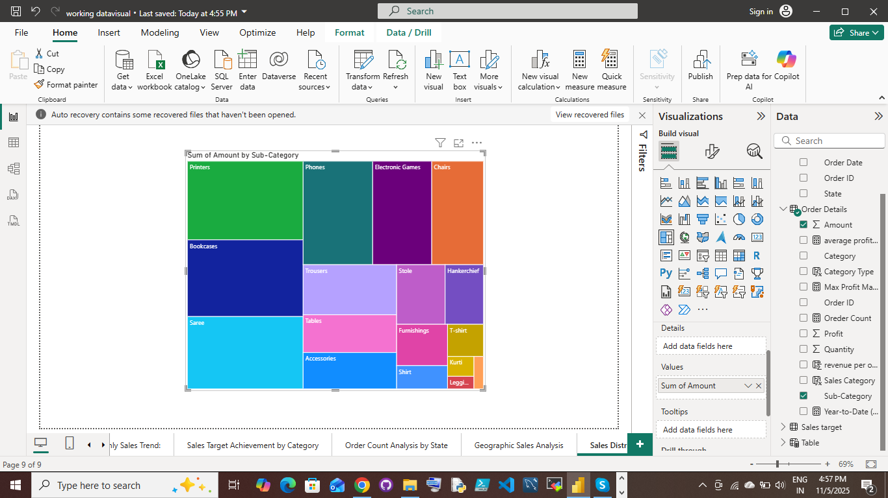

Order Count Analysis by State: Create a funnel chart to visualize the distribution of order counts across different states.
Screenshort:
